7.04.2020
Тема занятия: " Телевизионные каналы.Оборот how often.».
Задание.
1. Чтение текста и выполнение задания/
Read the text and complete it with the phrases (a-g) below.
а) This scans the screen
b) Live television programmes show you what is happening as it happens.
c) Baird showed his set in 1926.
d) These pass into the TV set.
e) Scientists have been interested in the idea of television since the 1880s.
f) Now nearly every home has one.
e) These tiny flashes of colour build up the picture on your screen.

Television
Television is a way of sending sound and pictures through the air. (1) --------- Although John Logie Baird was the first to show how television worked, his success was based on work by many other scientists from all over the world. (2) --------- The first television service opened in 1936 in Britain. Colour television began in the United States in 1956. At first, all television was black and white. Few people owned television sets because they were very expensive. (3) ---------- Television works by changing light waves into electric signals. This happens inside the TV camera. A picture of what is happening in front of the camera forms on a special screen behind the lens. Behind the screen is an electron gun. (4) ---------- It moves from left to right to cover each part of the picture. Each part is turned into an electric signal which is made stronger, then sent to the transmitter as radio waves. They are picked up by home TV antennas and changed back into electric signals. (5) ----------- The TV screen is covered with tiny chemical dots. In a colour set, these are arranged in groups of three: one red, one blue, one green. At the back there are other electron guns. These fire a beam of electrons to scan the screen just as the camera gun does. As each electron hits the screen, it lights up a dot. (6) ----------- You do not see lines of coloured flashing lights, because the electron gun moves too fast for the eye to follow. What you see is a picture of what is happening in the television studio. (7) ----------- Most programmes are recorded on film or videotape and sent out later.
2/Презентация проектов учащихся по темам: “My Favourite Film”, “My Favorite TV Programme” на электронную почту ursan82@mail.ru

8.04.2020
Тема занятия: "Багс Банни”-мой любимый мультфильм. Префикс un-.».
Задание.

1.Посмотрите отрывок из мультфильма. Подготовьте текст для озвучивания
https://yandex.ru/video/preview/?filmId=7720036408430723724&from=tabbar&p=1&parent-reqid=1586292478230307-689788892027180720000207-production-app-host-man-web-yp-216&text=Тема+занятия%3A+%22Багс+Банни”

2. Создайте свою версию данной серии.наложив свой текст на английском языке.
3. Готовый продукт прошу прислать на на электронную почту ursan82@mail.ru
4. Изучите теоретический материал

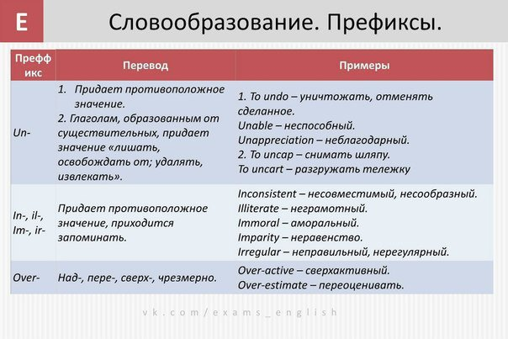
5. Выполните задание
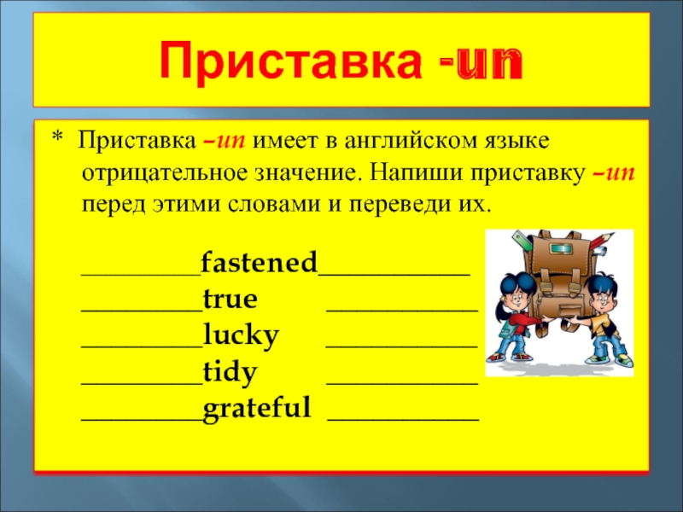

скриншот с результатами;
Каникулы в Риме. | 2 | 0,5 | 1,5 | 14
Приключения Гулливера. | 2 | 1 | 1 | 15
- индивидуальная беседа с педагогом в приложении whatsApp.

